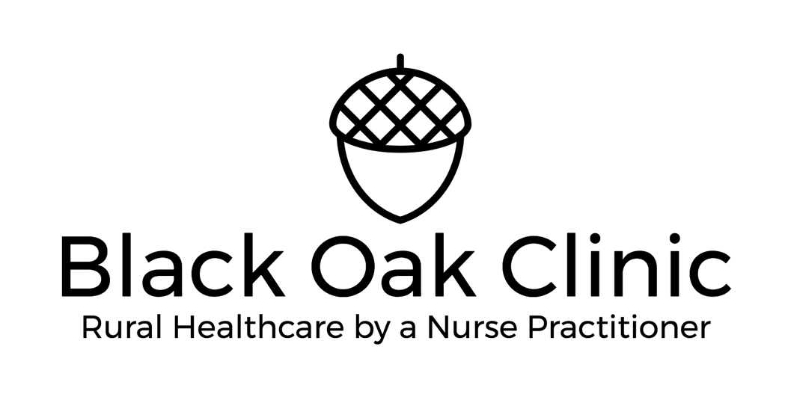
PLASMA PEN FIBROBLAST TREATMENT

I confirm that I am over 18 and that I have been advised of the following:
This treatment has not been tested on children, breast-feeding or pregnant women and is therefore not recommended in these cases. This treatment should be avoided if you have any serious underlying medical condition that prevents you from healing properly such as epilepsy, any infectious disease, diabetes, use of immunocompromising medications or treatments, hemophilia disorder, eczema, psoriasis, have used Accutane in the past year or retin-a, differin, or renova or similar product, taking medications that make you photosensitive, such as antibiotics or others. The treatment cannot be done if currently sick with any illness, must be in good health. It may not be done if you currently have eyelash extensions. This treatment is not recommended to be used on those clients with increased susceptibility to Keloid formation and hyper-trophic scarring. If you have ever had episodes of herpes simplex, it is recommended that you undergo a full course of antiviral treatments before you undergo this treatment. Consult your primary health care practitioner for the correct medications. This treatment is not recommended if you have a pacemaker, diabetic pump or a metal implant. Effects of this treatment for simultaneous use with peeling, Botox, laser or ultrasound-based treatments is unknown and should be avoided for at least two months after the last treatment. The area being treated must be free of any filling/filler product and there can be no tanning or recent sunburn in the last 30 days. This treatment is only recommended on Fitzpatrick Scales 1-3 and cannot be performed on darker skin because the risk of pigmentation issues is increased. This treatment should not be done if you are allergic to, or ever had any adverse reactions to topical lidocaine, benzocaine, tetracaine, salt, Dettol antiseptic solution, surgical or medical tape or latex.

It is imperative that aftercare instructions are followed as prescribed to minimize the likelihood of adverse reactions. There is a small risk of scarring, hypo-pigmentation or hyper-pigmentation which can be minimized but can never be completely avoided. However, these risks are greatly increased if the aftercare instructions are not strictly adhered to. Poor aftercare can cause serious detrimental results. The number of sessions required to achieve the desired result will be determined by the type of treatment you request, and the size of the area being treated. The minimum interval between treatments on the same area is 8 weeks. This minimum time period may be extended at discretion of your practitioner, depending on your skin type and your individual reaction to the treatment. Hypo-pigmentation is a normal reaction in skin renewal and normally disappears after a few months. These risks are minimized by following the after-care recommendations of avoiding sun exposure and applying total sun block each day for the next 8 weeks. In certain circumstances, red or pink spots where the treatment was carried out can develop and be visible for a few months, they can also be worsened by certain beauty products that can affect healing. These spots will eventually subside over time, but in the case that you tend to scar easier they could be permanent. This treatment can result in some immediate reactions including redness, major swelling and discomfort or tenderness. Discomfort usually lasts up-to 24 hours after the treatment, sometimes slightly longer. Swelling can last up to seven days. If any of these symptoms persist for more than eight days, or if any other side effects develop, report them to your practitioner. Long term redness and slight tenderness may continue for a few weeks to a few months following the treatment. Skin tightening procedures of any face or body area will probably scab up within 2-3 days. They may last for 10 days or more, but are usually gone by day 7, they are not to be removed manually or picked at as this can cause scarring. Treated areas may be a different color and texture than the surrounding skin until the total healing process is finished. The area may be tender for a day or two but should not be painful. Full correction is not always achieved in 1 session. De-hydrated skin tissue will have a tighter appearance immediately after the procedure. As the skin heals and rehydrates, the area will appear slacker than the immediate results, but will tighten as collagen grows. Subsequent treatments will advance the tightening effects. It is impossible to get the same exact results as you would with a surgical lift. We do not always do a patch test, but you may ask for one prior to your appointment for full treatment, forgoing a patch test does not make Black Oak Clinic LLC liable for any issues related to your treatment whether temporary or permanent. Also, a patch test may not be conclusive as to whether you will have a reaction or issue thereafter, you accept this and wish to proceed with treatment. During the treatment there may be an odor related to the plasma arc, there may be discomfort but every attempt to anesthetize the area will be made by the practitioner, some heat may be felt.

*Please name any allergies that you have, including foods and medications:

*Please list the medications you are taking:

The aesthetic practitioner provided me with sufficient information about the treatment in order to make an informed decision and I understand the risks involved. I understand that if I do not want to take those risks I can simply abstain from any treatment with the device. I have been given the opportunity to ask all of the questions I have about the treatments. The aesthetic practitioner has answered them to the best of his/her ability and I understand the answers. The aesthetic practitioner has provided sufficient time to consider whether I want to undergo the aesthetic treatment. The aesthetic practitioner has received relevant medical history information from me which I have answered to the best of my knowledge.
I understand the above directions and have been told what to expect and what to avoid. I acknowledge that it is my responsibility to promote common sense and cleanliness to prevent infection or scarring. I hereby agree that I will not hold the aesthetic practitioner/aesthetic clinic responsible for any actions that happen after I leave the establishment. I understand that I may call practitioner to ask questions about the procedure and after care during regular business hours Monday-Friday 9 am to 5pm @ 580-584-3099 or may use the patient portal, I understand that I cannot ask questions via social media as that forum is not HIPPA secure. I understand that if I have a complaint of any kind, I will email blackoakclinic@gmail and provide at least 14 days for them to respond to my complaint, I will give Black Oak Clinic LLC a chance to address my complaint or concern, before negatively referring to them in any public forum such as social media or online. I understand that I will need to send a picture to blackoakclinic@gmail.com at 2 weeks and again at 2 months. I understand that in order to minimize the risks of adverse reactions, especially pigmentation issues, I must use sunscreen PF50+ or greater daily, I will need to avoid products with any strong acid in them and any exfoliants for a minimum of 8 weeks, I will to avoid tanning/sun exposure and further cosmetic/aesthetic treatments for at least 8 weeks as well. I understand that I must follow all procedure/policies set forth by Black Oak Clinic LLC.

PHOTOGRAPHS
I authorize the taking of photographs and video footage and consent to the use of my photograms and video footage for any type of marketing free of charge. This consent form may be used for future visits.

I have read the above and consent to receiving the treatment at my own discretion.

Name in Print: __________________________________

Client’s signature: _______________________________

Date: _________________

